**Workshop 2: Telling Stories with Rumsey Maps and ArcGIS Online (AGO) Part 1 of 2 … The Basics of Web Maps**

**Prerequisites:**

* Active SUNetID
* Account with georeferencer.com on davidrumsey.com … you can make this account with your stanford.edu email address to make things easy.
* Supplementary workshop data

**1 - What is ArcGIS Online?**

ArcGIS Online (AGO) is a web mapping platform developed by ESRI, the same company that creates the ArcGIS Desktop suite of software. While AGO doesn’t contain the same high-powered analysis tools as Desktop, it’s a great platform for uploading your own spatial data, combining it with the data of others, adding multimedia like images and narrative text, and sharing your map with the public.

On AGO, you can create a **web map** and/or a **web app**. Slightly confusing, but different!

* A **web map** is the first thing you build--where you upload your spatial data, change the symbology or the basemap, and design pop-up information.
* A **web app** is a multimedia page that can contain one or more web maps, plus additional side panels, photos, or embedded content. **Story maps**, app templates with a strong narrative or comparison component, are a very popular category of web app.

Below are some examples of web apps with a historical emphasis.

* [New York City 1836 and Today](https://story.maps.arcgis.com/apps/StorytellingSwipe/index.html?appid=97ae55e015774b7ea89fd0a52ca551c2) (uses a Rumsey map! Spyglass contains historic image)
* [Katmandu Before and After the April 2015 Earthquake](http://story.maps.arcgis.com/apps/StorytellingSwipe/index.html?appid=97ab135daee04ee7bac9dac34f65277f) (slides between two ages of photos. Buttons on top left take you to “bookmarks” but user is free to scroll around)
* [USGS Historical Topographic Map Explorer](http://historicalmaps.arcgis.com/usgs/) (custom-built, way to search tons of georeferenced imagery and compare it)
* [Photogrammar](http://photogrammar.yale.edu/map/dots.php) (made with Leaflet not AGO, but still nice HGIS component)
* [Wonders of the Ancient World](https://storymaps.esri.com/stories/2018/wonders-ancient/) (story map, lots of narrative relative to spatial info)
* [The Real Pirates of the Caribbean](https://arcgis-content.maps.arcgis.com/apps/MapSeries/index.html?appid=c53486109eb84627b30d885935a8e66b) (story map using more than one web map)
* Japanese Military Maps: [Web Map App (Gallery)](https://stanford.maps.arcgis.com/apps/PublicGallery/index.html?appid=1ed3022fc7884690a2f137bce9dfe4fe) and specific example from [East Asia](https://stanford.maps.arcgis.com/apps/SimpleViewer/index.html?appid=adcafc202c894964a8a53df9baeffd90)

**2 - How do I log into ArcGIS Online (AGO) using my Stanford credentials?**

Go to the AGO sign-in page: <https://www.arcgis.com/home/signin.html>. Click “Sign in with Enterprise Login” at the bottom of the Sign In box.

Type “stanford” in the text box when prompted, so the organization URL reads “stanford.maps.arcgis.com.” Click Continue.

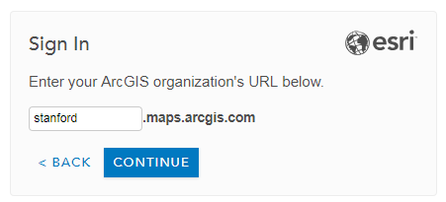

On the page that appears, click to sign in “using Stanford University”, *not* ArcGIS. You’ll be taken to Stanford’s familiar single sign-on page; enter your credentials normally. (You will probably have to use two-step authentication.)

After a successful sign-in, you are redirected to to the Stanford Geospatial Center AGO homepage! <https://stanford.maps.arcgis.com/home/index.html>

**3 - How do I add a georeferenced map from DavidRumsey.com as a layer in an AGO webmap?**

There are two steps involved here: (a) Getting the *WMTS link* for your map of choice from davidrumsey.georeferencer.com, then (b) Adding the link to that image as a layer on AGO

*3.1 - What is WMTS and why is it beneficial to use?*

WMTS (Web Map Tile Service) is a *protocol*, a URL / string of characters that delivers map image tiles from a remote server. One does not have to download their own copy of the georeferenced image and upload it anywhere. In fact, no image uploading is needed. WMTS results in faster image loading times because your image is broken up into tiles that are rendered only as the user pans over them. Another perk of tile services: You don’t need extra AGO account privileges to use WMTS links in your maps, whereas you *do* require additional privileges from your account administrator to publish your own image services.

*3.2 - Access the web map URLs for georeferenced Rumsey maps*

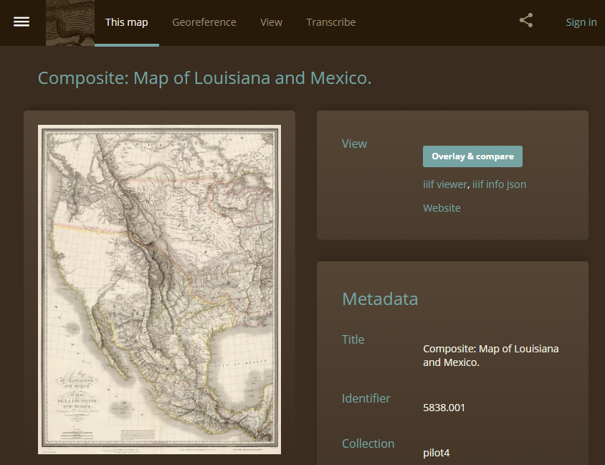

Navigate to your map’s Georeferencer.com metadata page, such as [this one](https://davidrumsey.georeferencer.com/maps/789923928072/).

* *How to get there:* Go to the map’s LUNA viewer [metadata page](https://www.davidrumsey.com/luna/servlet/detail/RUMSEY~8~1~207606~3003392:Composite--Map-of-Louisiana-and-Mex?sort=Pub_List_No_InitialSort%2CPub_Date%2CPub_List_No%2CSeries_No&qvq=q:5838.001;sort:Pub_List_No_InitialSort%2CPub_Date%2CPub_List_No%2CSeries_No;lc:RUMSEY~8~1&mi=0&trs=1) > Click the orange “View in Georeferencer” button > On the View page that appears, click “This Map” at the top of the window

Beneath the map on this page, under the heading “Use in GIS Apps”, click “Sign in to get links.”

* You’ll be prompted to sign into georeferencer.com with email, or Facebook, or Twitter… chose “Email”
* Provide the email address you want to associate with your Georeferencer account.
  + If you have a pre-existing account, provide your login credentials.
  + If you present a new email not already associated with a Georeferencer account, provide a name and password when prompted then click “Sign up”. You will be sent a confirmation email with a clickable link to verify your account.

After signing in, return to your map’s Georeferencer metadata page. A button should now appear under “Use in GIS apps” that reads “Get links.”

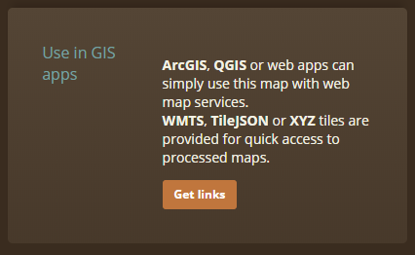

Clicking this button will reveal copy-able URLs in 3 formats: WMTS, TileJSON link, and XYZ link. Copy the Web Map Tile Service link (WMTS) text from the webpage.

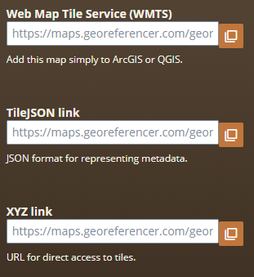

*3.3 - Add georeferenced map as a layer in my AGO webmap*

In a new browser window, navigate to stanford.maps.arcgis.com. Click “Map” in the top bar of this page to open a new online map.



You’ll be taken to a new, blank webmap. Take a look at the available toolbars and buttons.

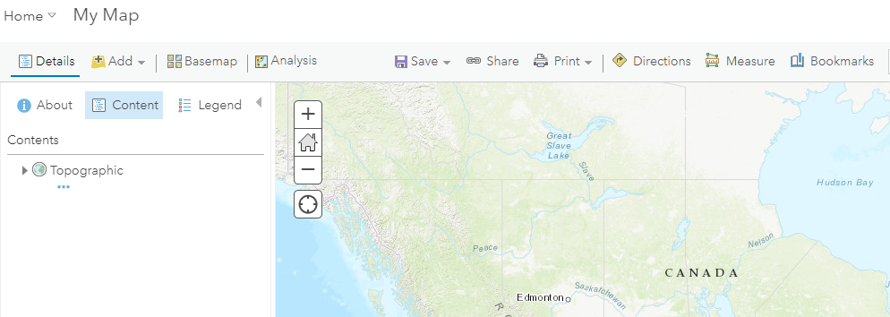

Click the “Add” button to add content to the map, then “Add layer from Web”

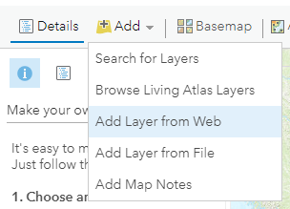

When asked what kind of data you’re referencing, select “WMTS OGC Web Service” from the drop down list. Paste your URL from georeferencer.com into the URL box. Click “Get Layers” then “Add Layer.”

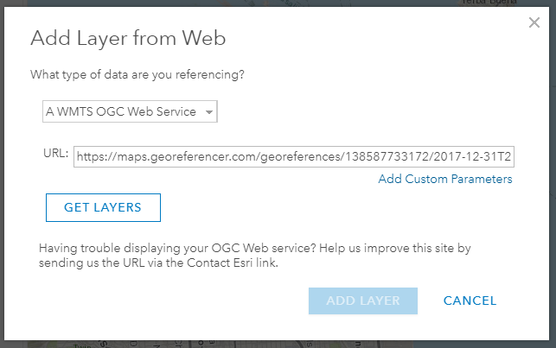

Your georeference map should now appear in your map document as well as in the document’s Table of Contents.

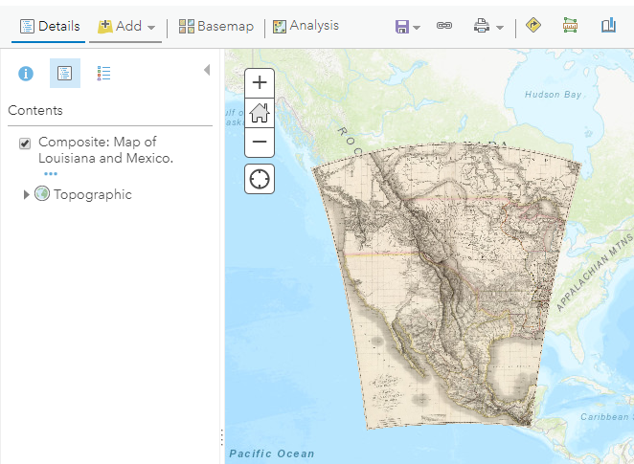

Now would be a good time to **SAVE** your AGO map. Click Save > Save As in the top menu bar.

In the Save Map dialog box that appears, title your map “Lewis and Clark’s Journey”.

Add some descriptive tags and a summary: these are required of all AGO maps. Ensure your map is being saved in the folder “*yourname*@stanford.edu_Stanford” --this is the personal Content folder connected to your AGO account. When finished, click “Save Map.”

**4 - How do I add spatial data from the ArcGIS Online community to my map?**

From your AGO map window, click the Add button then select “Search for Layers.” A new sidebar will appear to the left of your map, which by default shows layers you have saved in your AGO account. (There might not be much listed here if you haven’t used your account yet!) Click on the words “My Content” at the top of the box, and choose “ArcGIS Online” from the dropdown menu to instead browse layers uploaded by others.

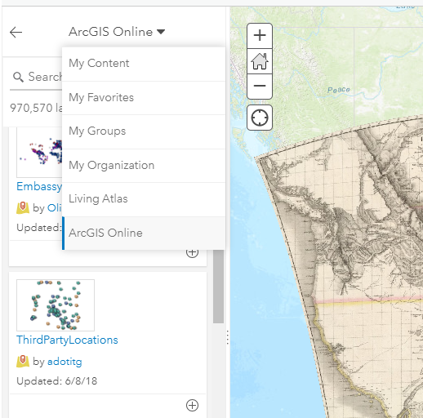

Type “lewis and clark route” into the “Search for layers” textbox and press Enter. Scroll to find the line-type dataset titled “Lewis and Clark Trail Historic Route”, added by user “rmcooper@nps.gov_nps”. Click on the title of the dataset to pull up a box containing its description, terms of use, and attribution information.

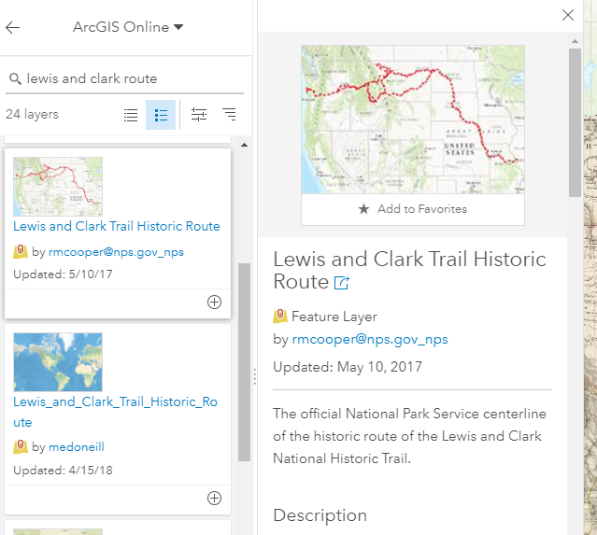

*Note about data credibility:* When searching for layers on AGO, *any* publicly shared layers from *any* AGO user may appear in the results. Thus, the accuracy and credibility of data found here may vary greatly depending on the data’s source. Here, we use the official reconstruction of Lewis and Clark’s travels by the US National Park Service based on historic imagery and primary documents. Be sure to read the metadata of any dataset you use to determine if it is best for your purposes.

Click the blue “Add to Map” button in the description window, then “X” to close the description window. The red line of the historic route should now appear atop your web map.

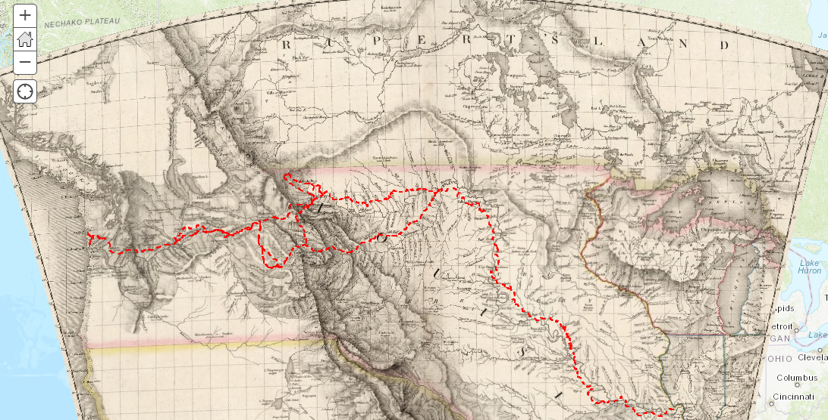

Click “Details” on the top menu bar to reopen your map’s table of contents in the page’s sidebar.

You can change the transparency of any map layer. Click on the three dots (“More options”) icon that appears when you mouse over “Lewis and Clark Map” in your table of contents, then select “Transparency” from the options menu. Adjust the slider to set your map image at 35-40% transparency.

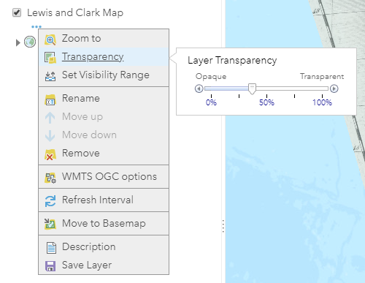

**SAVE** your AGO webmap!

**5 - How do I add spatial data from my computer to my web map?**

It is possible to add files from your computer as layers in your web map in two formats:

1. A *shapefile* (file extension *.shp*), geospatial data consisting of points/lines/polygons plus a table of attributes.
2. A *stand-alone table* (in .csv or .txt format) that contains XY coordinate locations, such as a latitude and longitude field.

For this demonstration, we will add a stand-alone table with lat-long coordinates. You can prepare a table on your computer with any additional information relevant to your project--place names, URLs to primary sources, short descriptions, and other categorical or quantitative variables.

On you computer, browse to the folder where your table resides. Double-click to open and inspect the document “poinst_tab.txt” in a simple text viewer such as Notepad.

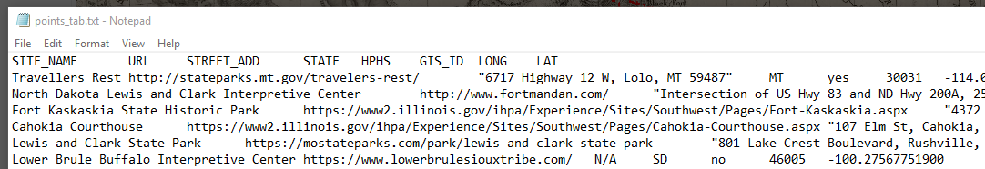

This jumble of letters is actually a spreadsheet--the first row denotes the column names, and each new cell/column is designated by a “tab” character. This was originally a simple Excel file that we exported to a TXT file.

The spatial components of this table are its latitude (y coordinate) and longitude (x coordinate) fields. When importing a table into AGO for eventual mapping, use straightforward heading names like LAT & LONG, LATITUDE & LONGITUDE, or Y & X. This allows AGO to auto-detect that the column contains spatial coordinates and plot the points automatically.

Close the table when you’re done viewing.

Return to your AGO map window in your web browser. Click the Add button then select “Add Layer from File.”

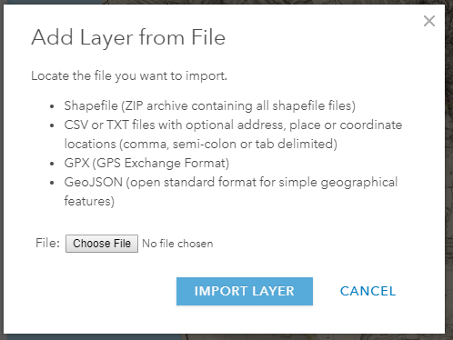

In the window that appears, click “Choose File” and browse to the location of the .txt file you just viewed. Select that .txt for upload, then click “Import Layer.”

Your map pane should now display point features representing historic places and visitor centers along Lewis and Clark’s historic route.

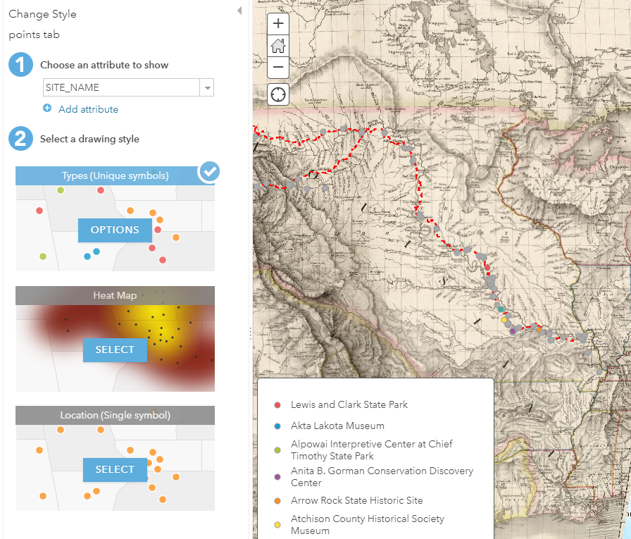

AGO auto-plots your XY points from your table, and then prompts you to Change the Style of these points. Upon import, points are often automatically symbolized according to the first field in the table--in our case, Site Name, which doesn’t make much sense. For now, we want to make all our points the same color.

From the *Choose an attribute to show* dropdown menu in the sidebar, choose “Show location only.” Next, under *Select a drawing style*, where Location should be already selected, click *Options*. In the new sidebar that appears, click the marker preview beside the word “Symbols” to open the symbol picker window.

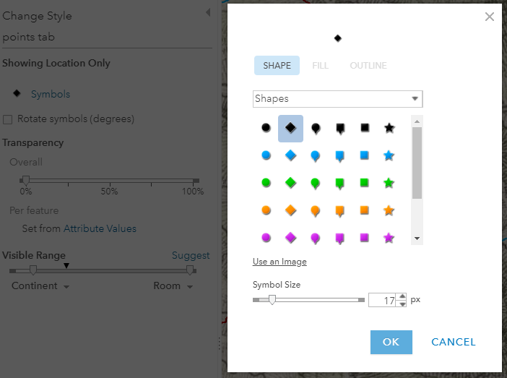

Choose a black diamond marker, size 17px, then click OK to close the window. Finally, click OK and Done to close the Change Style sidebar and return to your map’s Table of Contents. Lastly, we’ll rename this layer something more descriptive. Under your “points tab” layer, click the three-dots icon, then “Rename.” Call this layer “Visitor Centers & Museums”.

**SAVE** your AGO webmap!

*Note about adding shapefiles to AGO: This filetype is really 7 separate files that all must reside in the same file location to work properly (see screenshot below for an example called “points.shp”). AGO requires that these 7 components be held together in a zipped folder prior to upload. In Windows Explorer, select all files pertaining to “points.shp”, right click and select Send to > Compressed (zipped) folder. A file called “points.zip” should now appear in the same location as your original data.*

